[RESOURCE TITLE] Congruence of two Models

Objective 4.5: Understand that a two-dimensional figure is congruent to another if the second can be obtained from the first by a sequence of rotations, reflections, and translations; given two congruent figures, describe a sequence that exhibits the congruence between them.

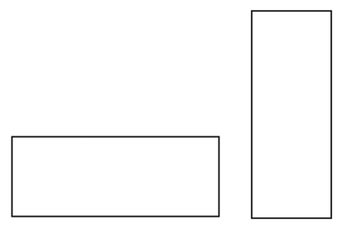[START FLASHCARDS]

Congruence: Two shapes are said to be congruent if one can be obtained from the other by a series of reflections, translations, and/or rotations.

Translation: Moving a shape from one location to another without changing its orientation.

Rotation: Turning a shape around, like spinning a record.

Reflection: "Flipping" a shape along one of its axes.

[END FLASHCARDS]

[MAJOR HEAD]Congruence

[INSERT FIGURE 2.2_8. ALT TAG: Two rectangles, one horizontal and one vertical. ]

[CAPTION] Two rectangles.

Take a look at these two shapes. What can you say about them?

Well, first of all, they're both rectangles. Are they different rectangles, or are they the same?

Your first instinct is probably to say "Of course they're different - one is wide and one is tall!" But take a closer look. Imagine picking up the rectangle on the left and turning it 90 degrees, and then sitting it back down again, so it is tall like the other one. *Now* are they different shapes?

It turns out, these two rectangles are exactly the same, they are just in different orientations. This concept is called *congruence*. Two shapes are said to be congruent if one can be obtained from the other by a series of one of three transformations.

When you think of congruence, imagine that you have a hole in the shape of the figure you're interested in - in this case, the rectangle on the left. Imagine that you have a hole that rectangle fits perfectly into, without changing anything about it. If you can pick up the rectangle on the right, turn it over, rotate it around, and adjust its orientation until it, too, fits into that hole, you've got a congruent rectangle.

Now, as mentioned, there are three transformations you're allowed to use when you think about congruence, and even though they have confusing names, you can think of all of them just like things you'd be able to do to a shape if you could pick it up in your hand. The three transformations are *Translation, Rotation,* and *Reflection.*

[MINOR HEAD]Translation

The first transformation is probably the most straightforward. Translation simply means to "shift" an object from one location to another. Imagine taking that rectangle, sliding it to the right three inches without changing the direction it's pointing. If you're working within the x-y plane, translation looks just like this:

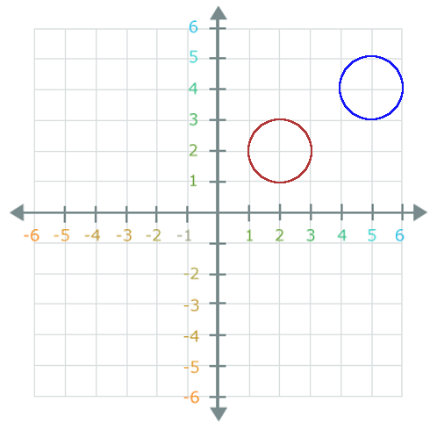[INSERT FIGURE 2.2_8. ALT TAG: Two circles in the x-y plane, one centered at (2,2) and the other centered at (5,4). ]

[CAPTION] Congruent circles in the plane.

Take a look at these two circles. It isn't too hard to see that if you take the red circle, slide it to the right 3 units on the x axis, and slide it up 2 units on the y-axis, it will exactly overlap the blue circle. So, you can obtain the blue circle from the red one by *translating* it (in other words, just by moving it around) - that's one of the transformations you can use to obtain congruent shapes, and so these two circles (of course) are congruent!

[MINOR HEAD]Rotation

Another of the transformations which can be used to obtain congruent shapes is rotation. Think of rotation like a spinning record on a turntable. Here's a quick example:

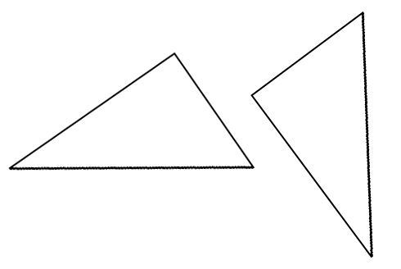

[INSERT FIGURE 2.2_8. ALT TAG: Two triangles, one wide and one tall. ]

[CAPTION] A pair of congruent triangles.

Imagine that you take the triangle on the left, and rotate it until the side that is on the bottom ends up on the right side. By rotating it, you can obtain the triangle on the right - these triangles are congruent!

[MINOR HEAD]Reflection

Reflection sounds like you're holding a shape up to a mirror, and that's kind of how it works. Imagine sitting a mirror down next to a shape, and looking at its reflection. If that's hard to visualize, here's an example:

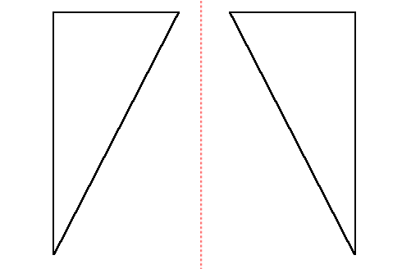

[INSERT FIGURE 2.2_8. ALT TAG: Two triangles, mirror images of each other. ]

[CAPTION] Reflected triangles.

Take a look at the triangle on the left, and imagine that the red dotted line is a mirror. In the mirror you see the reflection of the triangle - and that's how reflection works.

If it's easier, imagine that you can pick up the triangle on the left and "flip" it over. Reflection is like a "flip."

Now that you know the three transformations for congruent figures, it's time to start thinking of seeing them in combination with each other. For example: are these shapes congruent?

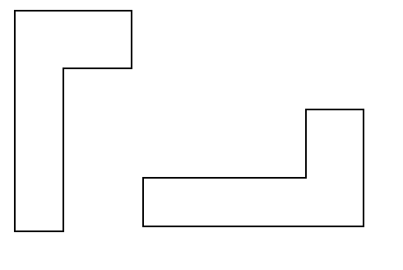

[INSERT FIGURE 2.2_8. ALT TAG: Two L-shaped figures. ]

[CAPTION] Congruent shapes.

It is possible to obtain the figure on the right from the one on the left - you need a reflection and a rotation.

To practice rotation, reflection, and translation, try cutting some shapes out of paper. Notice that you can move the shapes around, rotate them, and pick them up and flip them over, and the figure you end up with will always be congruent.

However, if you've cut a shape out of paper, can you stretch it, or make it uniformly larger or smaller? No you cannot - and these transformations are not allowed for congruent shapes, either. Anytime a shape is dilated, stretched, or skewed, the resulting shape is *not* congruent.

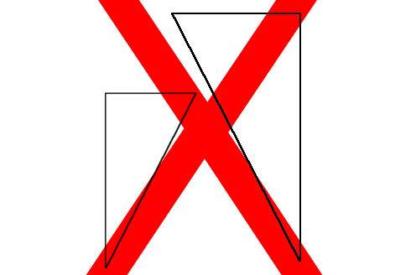

[INSERT FIGURE 2.2_8. ALT TAG: Two triangles which are similar, but not congruent. ]

[CAPTION] These triangles are not congruent.

Notice how these triangles seem like they may be reflections of each other, but one is smaller - this is a dilation, so these two triangles are *not* congruent. Be careful when identifying congruent figures -they have to be exactly the same.

If you get confused, think about fitting one into a hole exactly the size and shape of the other one. If you can't pick up either shape and, by turning it around and flipping it over, fit it exactly into the other one's hole, those shapes aren't congruent.

[RESOURCE TITLE] Key Points and Links

[MAJOR HEAD] Key Points

[BEGIN BULLETED LIST]

Two shapes are said to be congruent if one can be obtained from the other by a series of reflections, translations, and/or rotations.

Translations are just shifting a figure from one place to another. Rotations are spinning a shape like a record. Reflections are "flipping" a shape over, or making a mirror reflection.

Stretching, resizing, and skewing will *not* produce a congruent shape.

Imagine picking a shape up in your hand, flipping it over, turning it around, and putting it down exactly on top of another. If you can do that, the shapes are congruent.

[END BULLETED LIST]

[END KEY POINTS AND LINKS]

[START DISCOVER MORE]

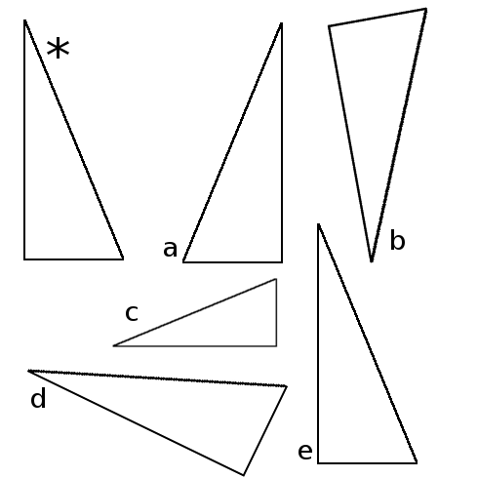

[INSERT FIGURE 2.2_8. ALT TAG: A series of triangles. ]

[CAPTION] Discover More Figure.

Begin with the triangle labeled with the asterisk (*). Identify the triangle which is:

1. Reflected only.

2. Translated only.

3. Rotated only.

4. Rotated and Reflected.

5. Not congruent.

[START DISCOVER MORE ANSWER]

1. a.

2. e.

3. d.

4. b.

5. c.

[END DISCOVER MORE ANSWER]

[END DISCOVER MORE]

[START SELF CHECK]

1. Which of the following is true about congruent figures?

A. They are the same shape and the same size.

B. They are the same shape, but not the same size.

C. They are the same size, but not the same shape.

D. They are not the same shape or size.

Explanation: Having the same shape and size are necessary for congruence.

2.

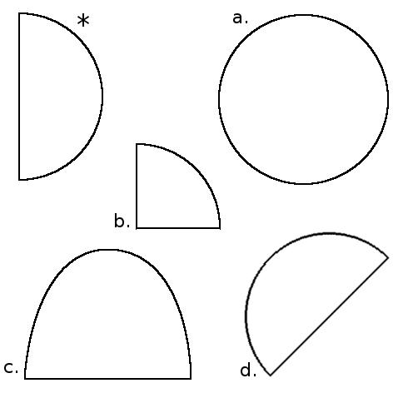

[INSERT FIGURE 2.2_8. ALT TAG: Figure. ]

[CAPTION] Figure.

Choose the figure that is congruent to the shape labeled with an asterisk (*).

A. Figure d.

B. Figure a.

C. Figure b.

D. Figure c.

Explanation: Congruence means the shape is exactly the same, aside from translations, reflections, and rotations. Shape d is the only congruent shape.

3.

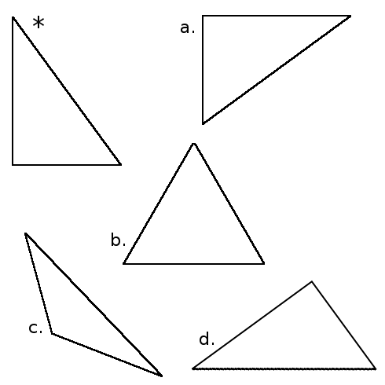

[INSERT FIGURE 2.2_8. ALT TAG: Figure. ]

[CAPTION] Figure.

Choose the figure(s) that is congruent to the shape labeled with an asterisk (*).

A. Figures a and d.

B. Figure a only.

C. None of the shapes are congruent.

D. All of the figures are congruent.

Explanation: Congruence means the shape is exactly the same, aside from translations, reflections, and rotations. Shapes a and d are both congruent.

4.

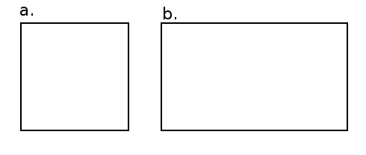

[INSERT FIGURE 2.2_8. ALT TAG: Figure. ]

[CAPTION] Figure.

Which of the following transformations, applied to figure a, will produce figure b?

A. None of these.

B. Reflection.

C. Translation.

D. Rotation.

Explanation: Figure b has been stretched - none of the allowed transformations for congruence will produce this.