Arithmetic Reasoning Section Overview

Word problems make up most of the Arithmetic Reasoning section of the AFOQT. To solve the problems, you will need to use reasoning and mathematics. You will be given a list of possible answers to solve everyday situations. Fractions, ratios, averages, percentages, and rates, are all things you will need to know to do well during this part of the test. Later in this chapter, you will have the chance to complete some practice problems that will help you be prepared for the real AFOQT.

PREPARATION STRATEGY

In this chapter, we will cover the necessary math skills you will need to solve each word problem. These are basic arithmetic elements that you may be proficient in already. You need to be able to read each word problem and know which tools to apply to get the correct answer.

Do not simply read through the problems without practicing them. Math requires practice to be competent. Make sure to do the practice questions and then compare your answers with the provided correct answers. Sometimes students read through the examples and think that they can do the problems. What matters is that you can do the problems on your own, not simply reading through examples. Note that many times there are multiple approaches to the same problem. As long as you get the correct response in a timely manner, don’t worry if you took a slightly different approach than in the answers provided.

CLASSIFICATION OF NUMBERS

**Numbers** are the substance that math is made of. Different classifications of numbers are used to communicate different math concepts. The following definitions of numbers will help navigate the language used in various operations of math.

**Whole numbers** are numbers with no fractions or decimals. 3 is a whole number. ¾ or .75, or 3.75 are not whole numbers. Also, whole numbers do not include negative numbers.

**Integers** are any positive or negative whole numbers, including zero. Decimals (.75 or 3.75), fractions (¾), or mixed numbers (3¾) are not integers. The difference between whole numbers and integers is that an integer can be negative (-1, -2, etc...).

**Factors** are the numbers you multiply together to get another number. For example, 1, 2, 4, and 8 are factors of 8 because $1×8=8,2×4=8.$ 1,2, 4, and 8, can be multiplied together to become 8, which makes them factors of 8.

**Remainders** are what is leftover when doing division. For example, dividing 3 by 2 would leave a remainder of ½. No remainder would exist if we divided 4 by 2. We will cover this in more detail later on in this chapter.

**Even number**: any integer that *can* be divided by 2 without leaving a remainder. Examples of even numbers are 2, 4, 6, etc...

**Odd number**: any integer that *cannot* be divided evenly by 2. Examples of odd numbers are 1, 3, 5 etc...

**Prime number:** any whole number greater than 1 that has only two factors, itself and 1. It can only be divided evenly by itself and 1. Examples of prime numbers are 2, 3, 5, 7. 4 is not a prime number because it could divided evenly by 2.

**Composite Number:** any whole number greater than 1 that has more than two factors. Essentially, a composite number is any number that is not a prime number. For example, 6 is a composite number because it can be divided evenly 1, 2, 3, and 6 (it’s factors are 1, 2, 3, and 6).

**Decimal Number**: any number that uses a decimal point to show part of the number that is less than one. For example, 2.33.

**Decimal Point**: a symbol used to separate the ones from the tenths place or dollars from cents in currency.

**Decimal Place**: the position of a number to the right of a decimal point. For example, in the decimal 1.345, the 3 is in the tenths place, the 4 is in the hundreds place, and the 5 is in the thousandths place.

**Digit**: any numeral 0 through 9.

**Rational Number**: A number which can be expressed as $\frac{a}{b}$ where *a* and *b* are *integers* is said to be rational. The rational numbers include all the integers, since any integer can be written as a fraction with a denominator of 1.

**Irrational numbers**: A real number which is not rational is, by definition, irrational. Some common examples of irrational numbers include $π,e,$ and . If written as a decimal, irrational numbers never repeat and never terminate. It may surprise you to know that *most* of the numbers that exist are irrational. For example, there are an infinite number of numbers between 1 and 1.000000001, and most of those are irrational.

**Real Numbers:** The real numbers are all of the rationals (and so, also all of the integers) together with the irrationals. If you were to throw a dart at a number line, with a very, very accurate measuring system, your dart would land on a real number. In fact, the only numbers that aren’t real are *imaginary* – and you won’t encounter those anywhere on a number line.

PLACE VALUE

When referring to specific digits in a number, it is important to understand what each place value is called. Below are the place values of each digit in the following number: 23,154.987

2: ten-thousands

3: thousands

1: hundreds

5: tens

4: ones

9: tenths

8: hundredths

7: thousandths

PRIMARY ARITHMETIC OPERATIONS

Four foundational arithmetic operations exist when working with numbers: addition, subtraction, multiplication, and division.

* Addition takes different numbers and combines them into a total, or sum. Sum means total when combining different collections into one. If there are 4 things in one collection and 5 things in the other, then after combining them, there is a total of $4+5=9$. Order doesn't matter when adding numbers. The equation could look like $5+4=9$.
* Subtraction is the opposite or inverse operation of addition. Addition combines numbers together, but subtraction takes one quantity away from the other. For example, if there are 12 eggs and 3 are removed, that gives us the equation $12−3=9$ eggs remaining. In subtraction, the order does matter because we need to know the amount that is being taken away and from which number it is being taken from.
* Multiplication can be thought of as repeated addition. For example, $5×3$ can be thought of as adding 5 sets of 3’s or 3 sets of 5’s. Another way to think about it is 3 sets containing 5 items, totalling 15. If you are more of a geometrical thinker, imagine a rectangle. 5 tiles wide and 3 tiles long. You have three rows of 5 tiles or you have 5 rows of 3 tiles. Either way, you will count 15 tiles. In multiplication, order of operation does not matter. $3×5$ is the same as $5×$ 3, both equal 15.
* Division is the opposite or inverse of multiplication. You take one quantity and divide it into sets that are the size of the second quantity. If there are 12 donuts to be given to 3 people, then each person gets $12÷3=4$ donuts. Order matters with division. $12÷3$ is different than $3÷12$.

PARENTHESES

Parentheses are used to designate which operation should be done first. For example, $5−\left(3−1\right)=3$; since $\left(3−1\right)$ is in parentheses, it is done first. $3−1=2.$ Then we subtract 2 from 5, $5−2=3.$ If we ignored the parentheses, the answer would be $5−3−1=1$. The right answer is 3, but if we ignore the parentheses, the answer is 1 which would be the wrong answer.

ADDITION

Addition is denoted with the $+$ symbol.

Addition follows the *commutative property*. This means that numbers can be added in different orders with the same result. For example: $5=3+2=2+3=5$. The formula for the commutative property of addition is $a+b=b+a.$

Addition also follows the *associative property*. This means that the grouping of numbers or the placement of parentheses does not matter. For example: $15=\left(5+3\right)+7=5+\left(3+7\right)=15$. The formula for the associative property of addition is $a+\left(b+c\right)=\left(a+b\right)+c$.

SUBTRACTION

Subtraction is denoted by the $−$ symbol. Subtraction involves taking one number away from another. The result is referred to as the *difference*.

Subtraction follows neither the commutative nor associative properties. In other words, the order of numbers and the placement of parentheses is important as it affects the outcome of an equation. Look at the examples below:

$$10=12−\left(6−4\right)$$

$$2=\left(12−6\right)−4$$

$$5=10−5$$

$$−5=5−10$$

In the above examples, remember to start with the numbers in parentheses first before moving on to the rest of the equation.

When working with larger numbers, it is helpful to regroup the numbers. Take for instance the problem below:

$$642−85$$

Let’s write this subtraction problem vertically, and group the numbers by column.

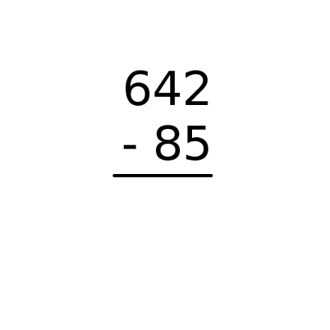

The ones and tens column of 85 (8 is in the tens column and 5 is in the ones column) is larger than the ones and tens column of 642 (6 is in the hundreds column, 4 is in the tens column, and 2 is in the ones column).

To simplify this formula, *borrow* from the hundreds column and the tens column.

When borrowing from a column, subtracting 1 from the lender column will add 10 to the borrow column.

First, borrow from the hundreds and add 10 to the tens…

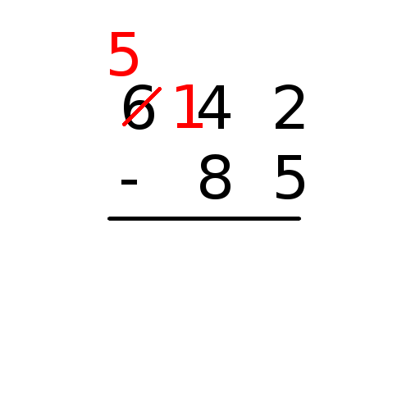

Then, borrow from the tens and add 10 to the ones…

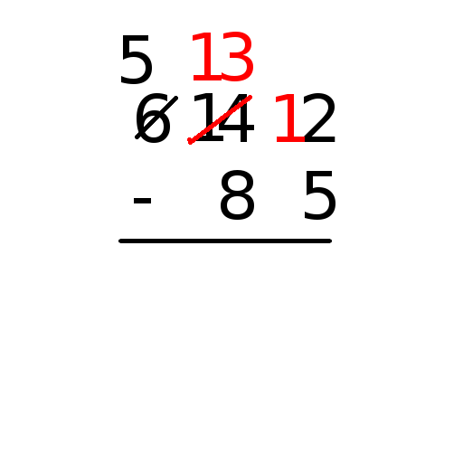

Then, you can subtract down the columns…

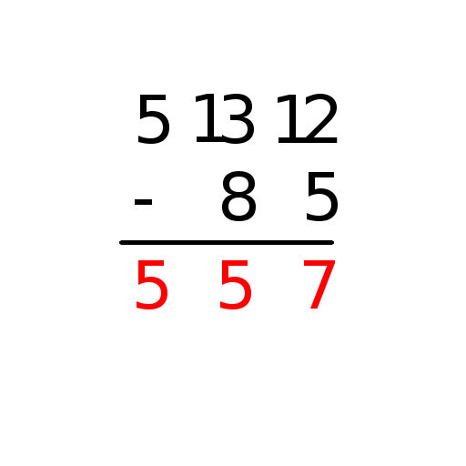

So, $642−85=557$.

As you can see, after borrowing, the digits in the top row will be larger than digits in the bottom row before proceeding. Honing this simple technique can help with subtraction involving larger numbers!

MULTIPLICATION

Multiplication is denoted by the $\left(⋅\right),\left(×\right),∨\left(\right)$ symbols. Also, multiplication is denoted by the use of parentheses next to a number. For instance: $5\left(4\right)=5×4=5∗4=5⋅4=20$

The numbers being multiplied together are referred to as *factors* and the answer or result is the *product*. In the equation $5×3=15$, 5 and 3 are factors. 15 is the product.

Like addition, multiplication follows the commutative and associative properties:

$$84=12×7=7×12=84$$

$$126=3×\left(7×6\right)=\left(3×7\right)×6=126$$

Multiplication follows the distributive property. The formula for distributive property of multiplication is $a×\left(b+c\right)=ab+ac$. In other words, when the sum of two numbers b and c is multiplied by a single number a, you can “distribute” the a by multiplying each of b and c by a, and then adding those products. This will give you the same answer as if you added b and c, and then multiplied that sum by a.

It is much easier to understand this by examining the following examples:

$$50=5×10=5\left(6+4\right)=\left(5×6\right)+\left(5×4\right)=30+20=50$$

$$117=9\left(7+6\right)=\left(9×7\right)+\left(9×6\right)=63+54=117$$

Sometimes, you will need to multiply large numbers. Thankfully, this can be done quickly thanks to an algorithm which is similar to the one we used for subtraction, above. Consider the following problem:

$$284×63$$

Let’s write this multiplication problem vertically, and group the numbers by column.

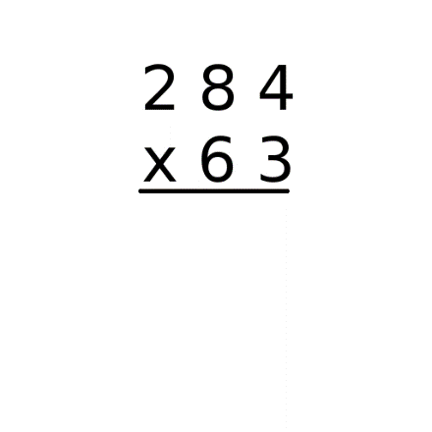

When you set up a multiplication problem like this, begin by writing the larger number on top of the smaller one, like this. Then, begin by looking at the number at the bottom of the ones column. In this case, it’s a 3.

This 3 is going to multiply *each* of the numbers above it, beginning with the ones (a 4), then the tens (an 8), and then the hundreds (a 2). Each number in the bottom will multiply each of the numbers above it in turn. This will become more clear as we proceed. Let’s begin by multiplying down the ones column.

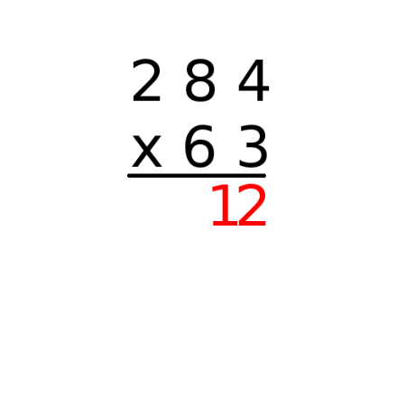

We got a two-digit number, but only one of those fits in the ones column – so, keep the 2, and “carry” the 1 to the top of the next column, in this case the tens.

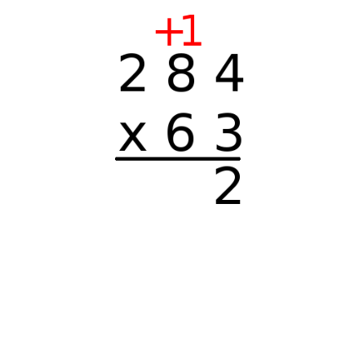

Next, multiply the 3 by the top number in the next column. 3 times 8 is 24, but don’t forget we carried a one, so we have to add it to the product after we’ve done our multiplication.

So, we have $8×3+1=25$.

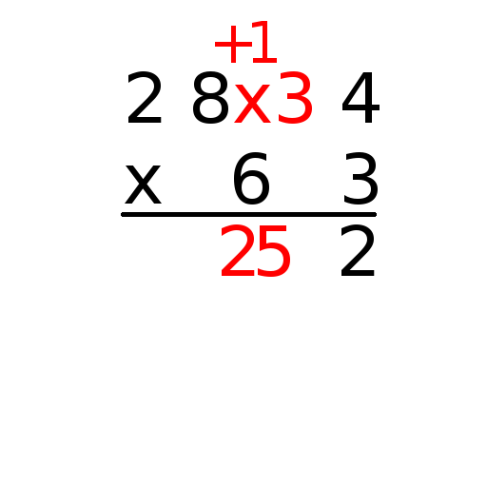

Once again, we’ll have to carry our second digit…

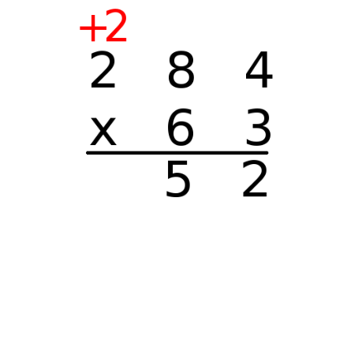

And repeat: $2×3+2=6+2=8$

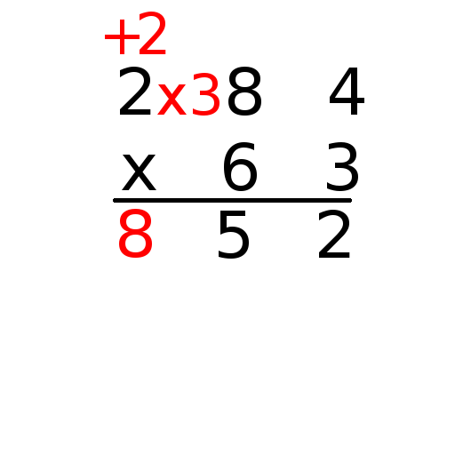

That takes care of the 3, but now we have to do the same thing in the tens column, and the 6 will need to multiply each of the numbers up top, carrying extra digits as we go. First, we add a zero to the ones column to signify that we’re working on the tens now:

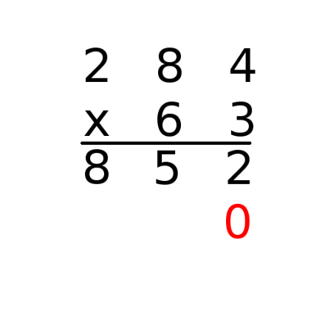

Then, we’ll multiply the 6 by each of the numbers up top and bring down those results. First, $6×4=24,$ and we will need to carry the 2.

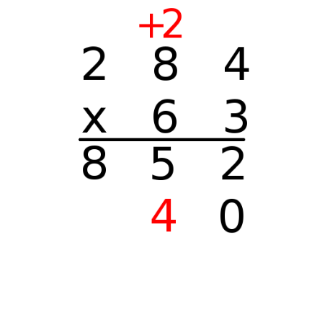

Then, $6×8+2=48+2=50.$ Likewise, we’ll carry that 5.

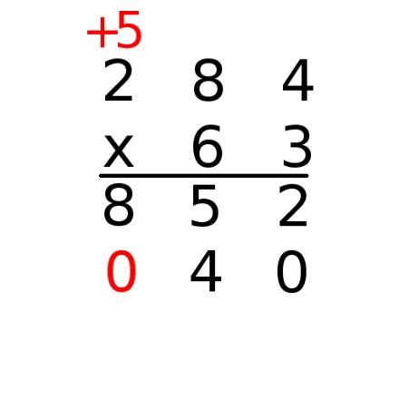

And finally, $6×2+5=12+5=17.$ Since this is our last column, the extra digit can just fall into place.

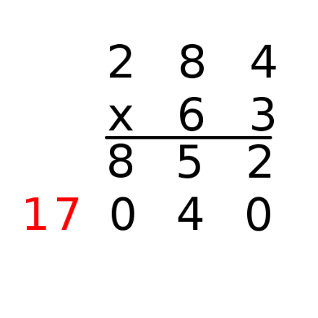

From here, just add the two numbers, carrying digits as necessary (but in this example, we don’t need to).

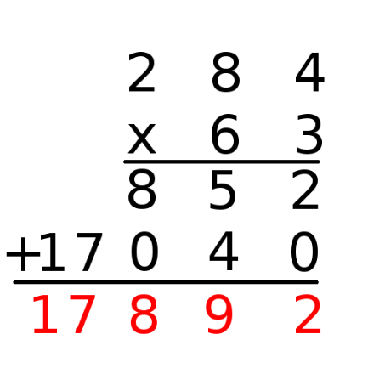

So, $284×63=17,892$.

DIVISION

Division is denoted by the $\left(÷\right)∧\left(\right)$ symbols. Much like addition and subtraction are opposite of one another, division is the inverse of multiplication.

Sometimes division can be denoted as one number over another one; in other words, as a fraction such as $\frac{5}{8}$. In this situation, the number on top is called the *numerator* and the number on the bottom is called the *denominator*. You may be accustomed to seeing fractions with a smaller number on top and a larger number on bottom, but something like $\frac{24}{8}$ is also valid. This fraction could be interpreted as $24÷8$. When written in this way, the number before the division symbol (24) is called the *dividend* and the number after the division symbol (8) is called the *divisor*. So, numerators are dividends and denominators are divisors.

Like subtraction, division does not follow the commutative property. It matters what number comes before or after the division symbol. It also does not follow the associative or distributive properties for the same reason. Here are some examples:

Division is not commutative; that is, $8÷4≠4÷8$:

$$8÷4=\frac{8}{4}=2.$$

$$4÷8=\frac{4}{8}=\frac{1}{2}.$$

Division is not associative; that is, $\left(48÷2\right)÷6≠48÷\left(2÷6\right):$

$$\left(48÷2\right)÷6=24÷6=4.$$

$$48÷\left(2÷6\right)=48÷\frac{2}{6}=144.$$

Finally, division is not distributive; that is, $\left(30÷2\right)+\left(30÷3\right)≠30÷\left(2+3\right):$

$$\left(30÷2\right)+\left(30÷3\right)=15+10=25.$$

$$30÷\left(2+3\right)=30÷5=6.$$

**Remainders**

In the above examples, we have largely been working with divisors which are factors of their dividends. For example, $30÷3=10$ because $10×3=30.$ However, often in division we will want to divide numbers which are not factors of their dividends, such as $30÷7.$ In this case, we wish to know what we must multiply 7 by to be as close to 30 as possible, without going over, and how much remains. The value left over, the value which remains, is called the *remainder.* In this case, $7×4=28,$ and there are 2 left over, so $30÷7=4$ with a remainder of 2.

Since division in the case of remainders can be a little less clear, often long division is a good way to approach division. It enables us to divide whole numbers into larger numbers more easily, and will naturally lead to a remainder if one exists.

**Long Division**

Long division is a method of division that develops an algorithm similar to what we have used when adding, subtracting, and multiplying larger numbers. Unlike those methods, we don’t write the numbers on top of each other in long division. Instead, we use the long division symbol:

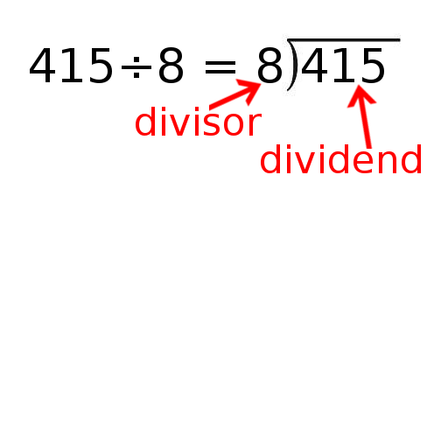

Once written this way, long division is a matter of dividing the divisor into each digit of the dividend individually, beginning at the left, and carrying over the value that remains in each column.

First, we consider $4÷8$.

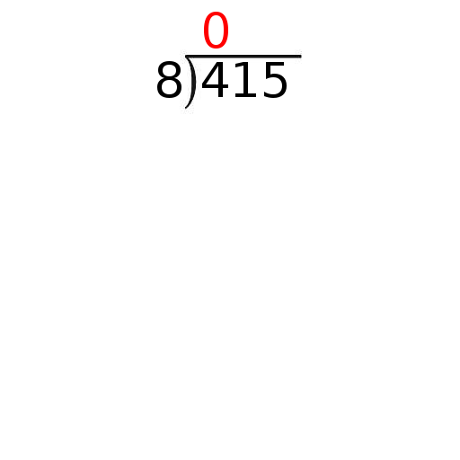

Since $8×1$ is too large, we must use $8×0$. Place the result below the first column, subtract, and drop down the next digit.

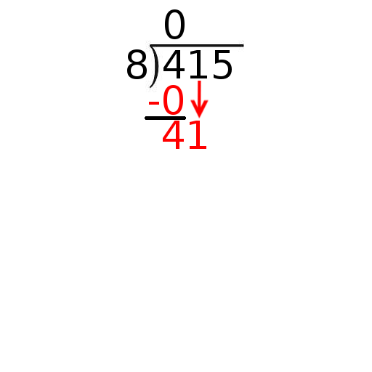

Next, we will consider $41÷8$, which is 5 (with a little left over).

Write a 5 up top. Since $5×8=40$, we subtract 40 from the 41 we have, leaving a 1, and drop down the next digit.

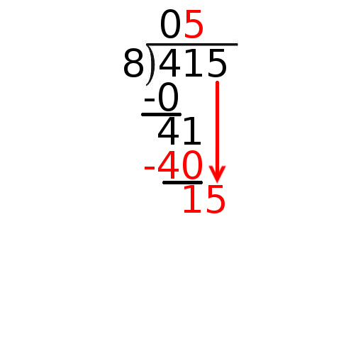

Now, 15/8 is 1, with a little left over.

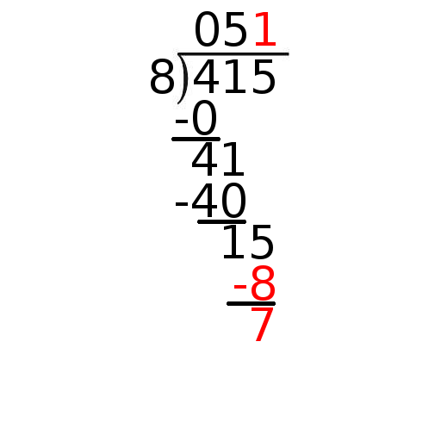

So, 415 divided by 8 is 51, with a remainder of 7.

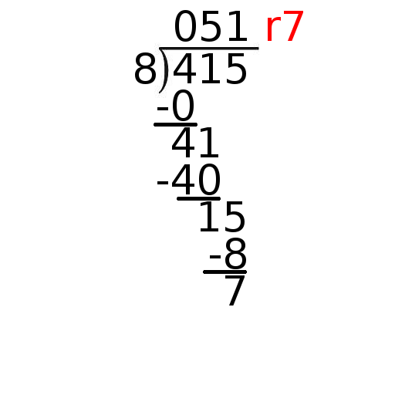

The number you get during division that isn’t the remainder is called the *quotient*. You can check your work, as well as illustrate the relationship between division and multiplication, by multiplying the divisor and quotient.

Divisor x Quotient + Remainder = Dividend

$$8×51+5=408+7=415$$

If you end up with a remainder of zero, your divisor is a *factor* of the dividend.

Using long division with remainders is a good way to divide large numbers.

FRACTIONS

A fraction is expressed as one integer on top of another with a dividing line between them ($\frac{x}{y}$). It can be thought of as x divided by y. It can also be thought of x number of parts out of y number of equal parts.

The top number is called the *numerator*. The bottom number is called the *denominator*. The denominator cannot be zero (this referred to as *undefined*).

**Simplifying Fractions**

Fractions can be simplified or reduced by dividing the numerator and the denominator by the same number. Fractions that have the same value but are expressed differently are known as equivalent fractions. For example, $\frac{2}{4}$, $\frac{4}{8}$, and $\frac{8}{16}$ are all equivalent fractions. By dividing the numerator and the denominator in each fraction by a common factor, they can all be reduced or simplified to $\frac{1}{2}$.

**Common denominators**

Sometimes fractions are manipulated so that they have the same denominator. This is known as finding a *common denominator*. The number that is chosen to be the common denominator should be the *least common multiple* of the two original denominators. Take for example $\frac{2}{5}$ an $\frac{2}{3}$. The least common multiple of 5 and 3 is 15; hence $\frac{2}{5}=\frac{6}{15}$ and $\frac{2}{3}=\frac{10}{15}$. Finding a common denominator can make addition and subtraction of fractions easier.

**Mixed numbers**

When the numerator is less than the denominator in a fraction it is known as a *proper fraction*. An *improper fraction* is one in which the numerator is greater than the denominator. Proper fractions have values less than one and improper fractions have values greater than one.

A mixed number is a number that contains an integer and a fraction. Because improper fractions have a value greater than one, any improper fraction can be rewritten as a mixed number. For example, $\frac{9}{4}=\frac{8}{4}+\frac{1}{4}=2+\frac{1}{4}=2\frac{1}{4}$. Also, any mixed number can be rewritten as an improper fraction. $1\frac{2}{5}=1+\frac{2}{5}=\frac{5}{5}+\frac{2}{5}=\frac{7}{5}$.

**Adding and subtracting fractions**

When two fractions have the same denominator, they can be added or subtracted by adding or subtracting the numerators and retaining the same denominator. For example, $\frac{1}{3}+\frac{2}{9}=\frac{3}{9}+\frac{2}{9}=\frac{5}{9}$. If the fractions do not have the same denominator they must be manipulated to achieve a common denominator before addition or subtraction takes place.

**Multiplying fractions**

Fractions can be multiplied by multiplying the two numerators to find the new numerator and multiplying the two denominators to find the new denominator. For example, $\frac{1}{2}×\frac{3}{5}=\frac{3}{10}$.

**Dividing fractions**

Two fractions can be divided by turning the second fraction upside down and proceeding with multiplication. For example, $\frac{1}{3}÷\frac{7}{8}=\frac{1}{3}×\frac{8}{7}=\frac{8}{21}$.

DECIMALS

**Adding and subtracting decimals**

When adding or subtracting decimals, it is important to align the decimals properly. Adding or subtracting decimals is just like adding or subtracting whole numbers. For example, $2.6+3=5.6$. If the decimals are not aligned properly, the answer may be written as 2.9 which would be incorrect and hurt one’s test score. Aligning decimals vertically can help:

2.6

+3.0

=5.6

Subtraction of decimals follows the same set of principles. Aligning the numbers vertically can help avoid incorrect answers:

5.6

-2.0

3.6

**Multiplying decimals**

Multiplication can be a little more challenging when multiplying numbers with decimals. One simple way to approach these problems is to ignore the decimals until the end and multiply the numbers as if they were whole numbers. After multiplying the factors, place the decimal in the product. The decimal placement is determined by adding up the total number of decimal places in the factors. To understand how this works, consider the examples below:

|  |  |  |
| --- | --- | --- |
| Example 1 | Example 2 | Example 3 |
|  |  |  |

Example 1: Ignore the decimal and multiply 35 by 22 to end up with 770 as the product. Next, add up the number of digits that follow a decimal in the factors. 3.5 and 2.2 both have decimals and one digit follows each decimal (5 and 2) for a total of **two** digits. In the product, we place a decimal **two** places to the left: 7.70. Since the zero is now unnecessary the answer (or product) is 7.7

Example 2: Ignore the decimal and multiply 12 by 17 for a product of 204. Count the number of digits in the factors that follow decimals. 1.2 and 1.7 have one digit each (2 and 7) that follow decimals for a total of **two** digits. Place the decimal **two** places to the left for a product of 2.04

Example 3: Ignore the decimal and multiply 8 by 2 for a product of 16. Count the digits in the factors that follow decimals. 00.8 has one digit that follows a decimal (the 8) and 2 has no digits that follow a decimal (it’s a whole number with no decimal) which gives us a total of **one** digit. Place the decimal to the left **one** place for a product of 1.6

**Dividing decimals**

To divide decimal numbers, multiply the *dividend* and the *divisor* by 10 until there are no decimals, and then solve the problem. Look at the example below:

$$4.2÷.7=42÷7=6$$

$$.244÷.061=244÷61=4$$

The process of long division for large numbers described earlier in the chapter applies here as well!

PERCENTAGES

Percent means “per hundred”. Percentages can be thought of as fractions with 100 being the whole. Percentages can be expressed as fractions. Simply divide the percentage by 100 and reduce the fraction to its simplest terms. For example, $56\text{\%}=\frac{56}{100}=\frac{14}{25}$; $20\text{\%}=\frac{20}{100}=\frac{1}{5}$

Additionally, fractions can be expressed as percentages. Simply manipulate the fraction so that it has a denominator of 100. This can be done by multiplying both the numerator and the denominator by the same number in order for the denominator to equal to 100. For example, $\frac{2}{5}=\frac{40}{100}=40\text{\%}$; $\frac{9}{10}=\frac{90}{100}=90\text{\%}$.

CONVERTING PERCENTAGES, DECIMALS, FRACTIONS

Sometimes problems require the conversion of percentages, decimals, or fractions. This section covers the process of these conversions.

**Converting percentages to decimals fractions and fractions**

When converting percentages to decimals, move the decimal point two places to the left. For example, $24\text{\%}=.24$; $2.5\text{\%}=.025$; $500\text{\%}=5.00$; $.22\text{\%}=.0022$

When converting percentages to fractions, divide by 100 and reduce the fraction into the simplest terms possible. For example, $20\text{\%}=\frac{20}{100}=\frac{1}{5}$; $15\text{\%}=\frac{15}{100}=\frac{3}{20}$; $7\text{\%}=\frac{7}{100}$.

**Converting fractions to percentages and decimals**

When converting fractions to percentages, multiply the numerator and denominator by a factor that will equal a product of 100 in the denominator. For example, $\frac{3}{5}=\frac{3×20}{5×20}=\frac{60}{100}=60\text{\%}$; $\frac{1}{4}=\frac{1×25}{4×25}=\frac{25}{100}=25\text{\%}$.

When converting fractions to decimals, multiply the numerator and denominator so that the fraction has a denominator of 100. For example, $\frac{7}{10}=\frac{7×10}{10×10}=\frac{70}{100}=.70=.7$; $\frac{1}{25}=\frac{1×4}{25×4}=\frac{4}{100}=.04$.

**Converting decimals to percentages and fractions**

When converting decimals to percentages, multiply the decimal by 100 or just move the decimal point two places to the right. For example, $.172×100=17.2\text{\%}$; $.7×100=70\text{\%}$; $.002×100=.2\text{\%}$

When converting decimals to fractions, multiply by $\frac{10}{10}$ until the decimal is gone and then reduce the fraction into its simplest possible terms. For example, $.12=.12×\frac{100}{100}=\frac{12}{100}=\frac{3}{25}$; $.0025=.0025×\frac{10000}{10000}=\frac{25}{10000}=\frac{1}{400}$ =; $.4=.4×\frac{10}{10}=\frac{4}{10}=\frac{2}{5}$.

RATIOS AND PROPORTIONS

**Proportions**

A proportion is the link between one quantity and how it changes in relation to the changes in another quantity.

*Direct proportion-* a set increase in one quantity for every increase in the other quantity. Also, a direction proportion could be a set decrease in one quantity for every decrease in the other quantity. For example, if you increase the amount of water poured into a bottle, the weight of the bottle will increase incrementally in *proportion* to the amount of water being poured. If you decrease the volume of water in the bottle, the weight of the bottle will decrease.

*Inverse proportion-* a set increase in one quantity for every decrease in the other quantity. Also, a direction proportion could be a set decrease in one quantity for every increase in the other quantity. For example, the darkness in a room decreases as light increases. Also, the amount of air in a cup increases as the water level decreases.

**Ratios**

Ratios quantify the comparison of two quantities. If there are 12 tacos and 6 people, the person to taco ratio is 6 to 12. This can be written as 6:12. Ratios should be reduced to their lowest whole number representation. In this case, 6:12 becomes 1:2 by dividing both sides by 6.

PROBABILITY

Probability is the likelihood of an event taking place. The higher the probability, the more likely the event is to take place. The lower the probability, the less likely the event is to place. Probabilities are expressed as a number or fraction between 0 and 1.

To demonstrate this, consider a coin. When flipped it can land as heads or tails. Since there are only two possible events, the probability of the coin landing on heads is 1 in 2 (.5, ½, 50%). Another classic example is a six-sided die roll. 6 possible events exist when rolling the die. The chance of rolling a 2 is 1 in 6 (⅙). Rolling any given number is a 1 in 6 chance. The probability of an event occurring is often calculated using the following equation:

*P(A)*= $\frac{Numberofacceptableoutcomes}{Numberofpossibleoutcomes}$

The total number of acetable outcomes must be less than or equal to the total number of possible outcomes. If the total number of acceptance outcomes is equal to the total number of possible outcomes then the probability of the event happening is certain and equal to 1. If the number of acceptable outcomes if zero then the probability of the event occurring is impossible of the probability is equal to 0.

MEASURES OF CENTRAL TENDENCY

Data tends to cluster towards the middle of probability distributions. Central tendency describes these middle values. Three common measurements are taken to find these middle or “average” values. These common measurements are mean, median, and mode.

**Range**

When given a data set of numbers, the *range* is the difference between the highest and lowest number. For example, if given data set is {2, 4, 9, 12, 19, 40}, the range is 40-2=**38**.

**Mean**

The mean is what is commonly referred to as the average of a data set. Simply add up all the numbers in the data set and divide by the quantity of values in the data set.

*Mean*= $\frac{\sum{of}datavalues}{Quantityofdatavalues}$

For example, if the data set is {4, 3, 9, 4, 1}, the formula to find the mean would be as follows:

$\frac{4+3+9+4+1}{5}=\frac{21}{5}=$ 4.2

Mean doesn’t always give an accurate picture of what the data is communicating. If you were given a data set of ages amongst 5 people that looked like this {7, 5, 4, 9, 99}, the average age would technically be 24.8 which really does not depict the age of the group very well. The 99 year old person is what is known as an outlier, a value that is far outside the majority of the values. To communicate a more comprehensive picture of the data, the median and mode are used in conjunction with the mean.

**Median**

The median is simply the middle value of a data set. For example, if the data set is {17, 15, 20, 22, 14}, begin by rearranging the data from smallest to largest {14, 15, 17, 20, 22}. Since the quantity of values is odd (five total values), then the middle value (17) is the median. If instead of five values there were six values, then the median would be the mean of the two middle numbers. For example, the data set had a 16 in it { 14, 15, 16, 17, 20, 22}, the median would be $\frac{16+17}{2}$ =16.5

**Mode**

The mode is one more measurement of a data set. The mode is simply the value that appears the most number of times. If all values appear the same number of times, then there is no mode. If one value appears more times than any other value then that value is the mode. If two or more values appear an equal number of times in respect to one another but more than the rest of the values, then those values are the modes.

Here are three examples:

1. The mode of this data set is 5 since it appears most frequently: {5, 4, 7, 4, 5, 6, 8, 5, 2, 3,1, 2}
2. This data set has no mode because all values appear an equal number of times {2, 4, 1, 6, 7, 9}
3. The mode of this data set is 3 and 5 because those two values appear an equal number of times in respect to one another, yet more than the rest of the data set: {3, 7, 5, 9, 5, 3, 8, 4}

REAL WORLD (MULTIPLE STEP) PROBLEMS

**Example 1**

A patient in the emergency room is given 1000 mL of fluids every two hours. What quantity of fluids will the patient receive after 5 hours?

Using proportional reasoning, since 5 hours is 2.5 times as long as 2 hours, then the patient will receive 2.5 times the amount of IV fluids, so 2.5 x 1000 = 2500 mL in 5 hours.

To compute this answer methodically, begin by writing the amount of IV fluids per 2 hours as a proportion:

$$\frac{1000mL}{2hours}$$

Then, create a proportion to relate the two time increments, labeling the unknown quantity with *x:*

$$\frac{1000mL}{2hours}=\frac{xmL}{5hours}$$

Make sure when you make a proportion to keep the numerator and denomonator’s units consistent with each other (in this case, mL up top and hours in the bottom).

$$\frac{1000mL}{2hours}=\frac{xmL}{5hours}$$

$$1000\left(5\right)=2x$$

$$5,000=2x$$

$$5,000÷2=2x÷2$$

$$2500=x$$

So, this patient should receive 2500 mL of fluids every 5 hours.

**Example 2**

In one yoga class, there are 12 female students and 9 male students. The evening class which is much larger, happens to have exactly the same student ratio. If there are 48 female students in the evening class, how many male students are there?

$$\frac{numberoffemalestudents}{numberofmalestudents}=\frac{12}{9}=\frac{48}{numberofmalestudents}$$

Then, write the number of male students as x.

$$\frac{12}{9}=\frac{48}{x}$$

$$12x=48\left(9\right)$$

$$12x=432$$

$$12x÷12=432÷12$$

$$x=36$$

**Example 3**

In a restaurant, there are 4 servers for 12 tables. If the restaurant were to expand to 24 tables, how many servers would they need to hire to ensure the quality of service does not suffer?

The ratio of servers to tables can be written as 4 to 12, or as 4:12, or as $\frac{4}{12}$ Since 12 and 4 share a common factor of 3, we can reduce this ratio to 1 to 3, or 1:3 or $\frac{1}{3}$. If this ratio were to remain constant, in order to cover $3×8=24$ tables, they will need $1×8=8$ servers.

**Example 4**

What is 20% of 160?

In this problem, the word *of* tells us that multiplication is happening, so you can find 20% of 160 by multiplying 160 by 20%. Convert the percentage into a fraction or decimal: $20\text{\%}=0.20=\frac{20}{100}=\frac{1}{5}$. Then, multiply:

$$160×0.20=32,$$

or:

$$160×\frac{1}{5}=\frac{160}{5}=32.$$

**Example 5**

What is 130% of 70?

In this problem, the word *of* tells us that multiplication is happening, so you can find 20% of 160 by multiplying 70 by 130%. Convert the percentage into a fraction or decimal: $130\text{\%}=1.30=\frac{130}{100}=\frac{13}{10}$. Then, multiply:

$$70×1.30=91,$$

or:

$$70×\frac{13}{10}=\frac{910}{10}=91.$$

**Example 7**

An employee is making $88 per day, and then is given a raise. After the raise, the employee is making $100 per day. What was the percentage increase of the employees’ daily wages?

The wages increased by $12:

$100-$88=$12

To find a percent increase (or decrease), we use $\frac{newamount−originalemount}{originalamount}$

$\frac{100−88}{88}=\frac{12}{88}=0.136136≈13.6\text{\%}$

**Example 8**

BASIC GEOMETRY

Geometry is the area of mathematics that deals with the shape, size, and relationships between objects in defined spaces. The most basic unit in geometry is the point.

A **point** is a fixed location. Since it is a place and not a thing, it has no size or dimension. It is represented by a dot and usually is labelled with an uppercase letter.

A **line** isdefined by two points. A line is a figure that passes through both points and has no beginning and no ending that extends in both directions.

A number of points which lie upon the same line are said to be **colinear*.***

A **line segment** is a portion of a line that has two endpoints.

A **ray** has one endpoint and then continues infinitely in the other direction.

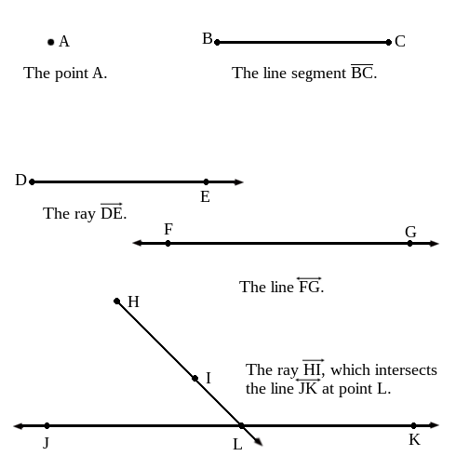

A **plane** is a flat, two-dimensional surface extending infinitely in both directions. Just as a line may be defined by two points, a plane may be defined by three points.

A number of points, lines, rays, or line segments which lie on the same plane are said to be **coplanar.**

**Parallel Lines** are defined as being two or coplanar lines which have no points in common, and which never meet.

Two lines which have exactly one point in common are called **Intersecting Lines.**

More than two lines which have exactly one point in common are called **Concurrent Lines.**

A **Transversal** is a line which intersects at least two other lines. Transversals which intersect parallel lines are useful tools in geometry, so we use them often.

When two lines or line segments intersect at a single point, they can be said to intersect at an **Angle.** Angles are commonly represented by the symbol ∠. The point at which two lines, segments, or rays intersect to form an angle is called the **vertex** of that angle.

A **Right Angle** is an angle whose measure is 90 degrees.

Lines that intersect at an angle of 90 degrees (a right angle) are said to be **Perpendicular.**

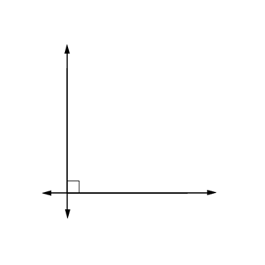

An **Acute Angle** is an angle that measures less than 90 degrees.

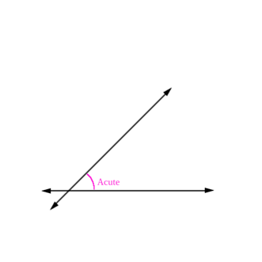

An **Obtuse Angle** is an angle that measures greater than 90 degrees, but less that 180 degrees.

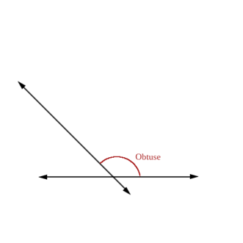

A **Straight Angle** is an angle that measures exactly 180 degrees. It looks like a straight line and sweeps out a semicircle, or half-circle.

A **Reflex Angle** is an angle that measures greater than 180 degrees, but less than 360 degrees.

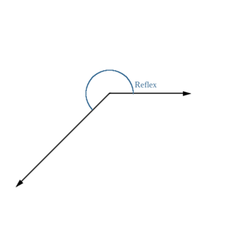

A **Full Angle** measure 360 degrees, and sweeps out a full circle.

**Classifying Figures**

**Squares and Rectangles**

Squares and rectangles are **quadrilaterals**, or four-sided figures, made of perpendicular and parallel lines. If you take a square or rectangle and pick two sides going different directions, those lines are perpendicular. This tells you that all the angles in a square or rectangle are right angles! If you pick two lines going the same direction, those lines are parallel.

**Parallelograms**

Parallelograms have the word parallel in the name, so you shouldn't be surprised to find parallel lines in them.

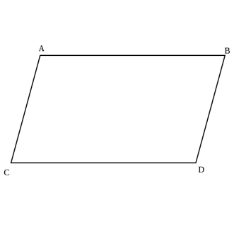

In the parallelogram shown in the figure, the sides AB and CD are parallel, and the sides AC and BC are parallel, too. In a parallelogram, each pair of opposite sides are parallel. Squares are rectangles are a special kind of parallelogram, but not all parallelograms are squares or rectangles.

A parallelogram whose sides are all the same length is called a **Rhombus**.

**Trapezoids**

A trapezoid is a figure with two parallel sides, and two sides that intersect. It has no perpendicular lines. In the given trapezoid, the lines AB and CD are parallel, but the lines AC and BD intersect.

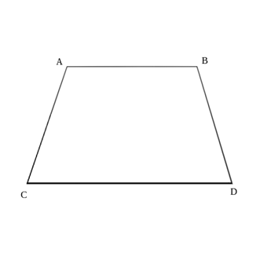

**Triangles**

A triangle is a figure with three sides. Triangles will never have any parallel lines. However, sometimes a triangle may contain perpendicular lines. Such a triangle is called a **right triangle**.

**Right Triangles**

A right triangle is a triangle in which two of the sides form a right angle.

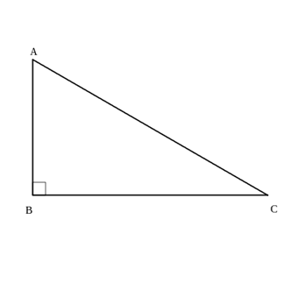

In a right triangle, the length of the longest side (AC) is called the **Hypotenuse**. If you know the length of 2 of the 3 sides of a right triangle, you can figure out the length of the third side using the **Pythagorean Theorem:**

$$a^{2}+b^{2}={c^{2}}^{}$$

In this formula, a and b are the lengths of the shorter 2 sides, and c is the length of the hypotenuse.

**Note:** When talking about angles, the letter in the middle is the point where the angle happens. For instance, in the triangle figure, the angle ABC is a right angle, but the angle ACB is not - it's acute.

**Areas of Polygons**

**Polygon:** a figure composed of a shape with distinct sides and angles.

**Vertex**: In a polygon, any point where two sides intersect at an angle.

**Altitude**: The vertical height of a polygon.

**Rhombus**: A parallelogram whose sides are all congruent.

**Kite**: A quadrilateral whose pairs of adjacent sides are congruent.

**Interior angle**: The angle formed by the vertex of two sides of a polygon, measured in the interior of the polygon.

**Regular polygon**: A polygon all of whose sides and interior angles are congruent.

***n*-gon**: a polygon with *n* sides (for example, an 11-gon is a polygon with 11 sides).

**Radius of a regular polygon**: The distance from the center of a regular polygon to any of its vertices.

**Central angle of a regular polygon**: The angle formed by two radii leading to adjacent vertices.

**Apothem**: A line segment which bisects the central angle of a regular polygon, perpendicular to the side it intersects.

**Squares and Rectangles**

The area of a square is equal to the square of the length of one side, or simply $A=s^{2}$*.*

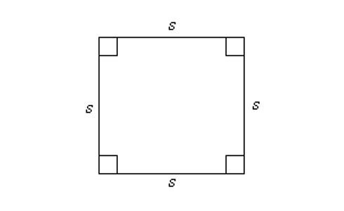

The area of a rectangle is similar to the area of a square; it is equal to the product of its length and width. You may also think of this as “base times height” or “side times side.” Typically, the longer side is designated the “length” and the shorter side is the “width,” and so for a rectangle, you can write $A=lw$.

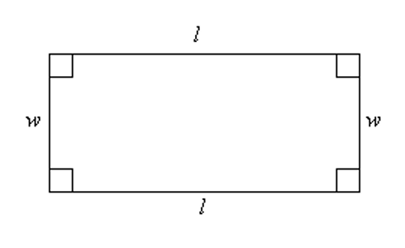

To find the area of a triangle, first choose one of the sides to be the base, *b*. Then, by taking a line perpendicular to the base rising up to the vertex above it, we find the altitude, or height, *h*, of the triangle.

The area of any triangle is equal to one half of the product of the base and the height, so your formula is $A=\frac{1}{2}bh.$

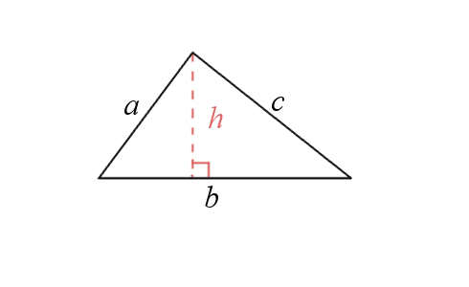

In order to determine the area of a parallelogram, you’ll need to combine what you already know about rectangles and triangles. Notice that if you draw a perpendicular line from one corner of the parallelogram to its base, you can create a right triangle with altitude *h*. Doing the same from the other corner creates a rectangle with length *l* and width *h*.

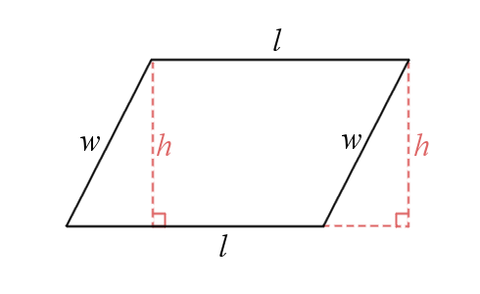

By “cutting off” the right triangle on the left, and pasting it into the triangle-shaped area on the right, we will have a rectangle that must have the same area as the parallelogram. So, the area of the parallelogram is simply the area of this rectangle: $A=lh.$

**Area of a Rhombus or Kite**

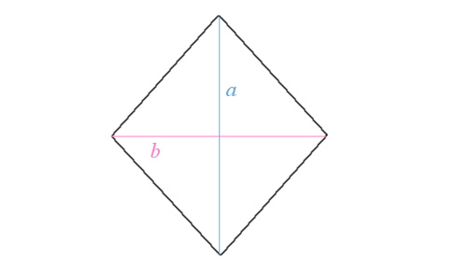

A rhombus is a special kind of parallelogram whose sides are all the same length. In order to find the area of a rhombus, you need to find the lengths of its diagonals. In the given figure, the rhombus has diagonals *a* and *b*.

Notice that these diagonals divide the rhombus up into four right triangles, each with base ½ *b*, and height ½ *a*. Based on what you know about triangles, each of these triangles will have area of *(1/8) ab.* Since the combined areas of these four congruent triangles is the same as the area of the rhombus, the area of the rhombus must be $4\left(\frac{1}{8}ab\right)=\frac{1}{2}ab$. So, for a rhombus, $A=\frac{1}{2}ab$.

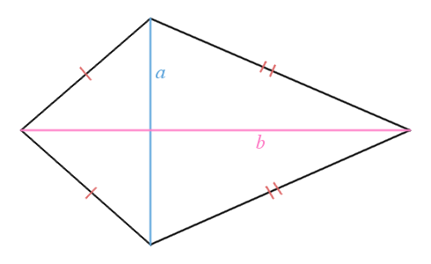

A kite is a quadrilateral with two pairs of congruent adjacent sides. A kite differs from a rhombus in that it is not a parallelogram, but because it can be broken up into four right triangles with the use of its diagonals, the area of a kite can be found using exactly the same formula as the rhombus. So, for a kite, $A=\frac{1}{2}ab$.

Let’s review the areas in a single table:

|  |  |
| --- | --- |
| Square | $$A=s^{2}$$ |
| Rectangle | $A=lw$ (where l is length and w is width) |
| Triangle | $A=\frac{1}{2}bh$ (where b is the base, and h the altitude or height) |
| Parallelogram | $A=lh$ (where l is the length, and h is the altitude or height) |
| Rhombus | $A=\frac{1}{2}ab$ (where a and b are the lengths of its diagonals) |
| Kite | $$A=\frac{1}{2}ab$$ (where a and b are the lengths of its diagonals) |

**Angle Measure in Regular Polygons**

A polygon whose angles and side lengths are all equal is called a *regular polygon*. A polygon that isn’t regular is called *irregular*. This is a regular hexagon (left), and an irregular hexagon (right).

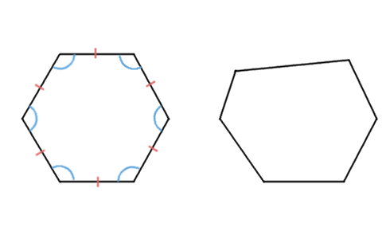

Polygons are named according to the number of sides they have. Since the polygon in the figure has six sides, it’s a hexagon. The hexagon on the left has all its sides congruent, and all its interior angles are congruent. Every angle in this regular hexagon will have the same measure. However, if you were to draw a regular octagon (that is, a regular eight-sided polygon), the interior angles, while congruent with each other inside the octagon, would be different from those in the hexagon.

In order to learn how to find the measure of the interior angles of a regular polygon, consider this table. All polygons in this table are considered to be regular polygons.

|  |  |  |
| --- | --- | --- |
| Number of Sides | Regular Polygon Name | Interior Angle Measure |
| 3 | Triangle | 60o |
| 4 | Quadrilateral | 90o |
| 5 | Pentagon | 108o |
| 6 | Hexagon | 120o |
| 7 | Heptagon | 128.57o |
| 8 | Octagon | 135o |
| 9 | Nonagon | 140o |
| 10 | Decagon | 144o |
| ... | ... | ... |
| *n* | *n*-gon |  |

**Areas of Regular Polygons**

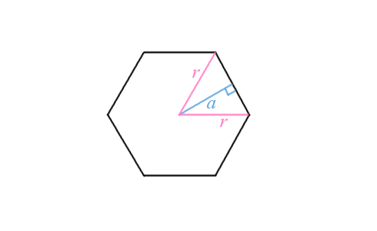

Just as a circle has a radius, a regular polygon will also have a radius. The distance from the central point to any of the vertices is the *radius* of a regular polygon. The angle formed by two radii to two adjacent vertices in a regular polygon is called the *central angle*.

Notice in the figure the segment labeled *a*. This is a line segment which bisects the central angle and is perpendicular to the side it intersects. This is called the *apothem* of a regular polygon.

Since taking repeated radii and apothems splits the regular *n*-gon into a number of triangles, you can use similar methods to the one used for the rhombus to determine that the area of a regular *n*-gon is one half the product of the apothem’s length and the polygon’s perimeter.

So, for a regular *n*-gon, $A=\frac{1}{2}pa$.

**Three-Dimensional Figures**

We encounter solids every day in our real life. A can of soup is basically a cylinder, and a brick is basically a cuboid (that is, a six-sided solid with rectangular sides). By studying geometric solids, we can learn about the physical world around us.

In geometry, a solid is a three-dimensional figure that has width, height, and depth. Some classic examples include the cube, sphere, cylinder, cone, and pyramid.

Here are some examples of geometric solids.

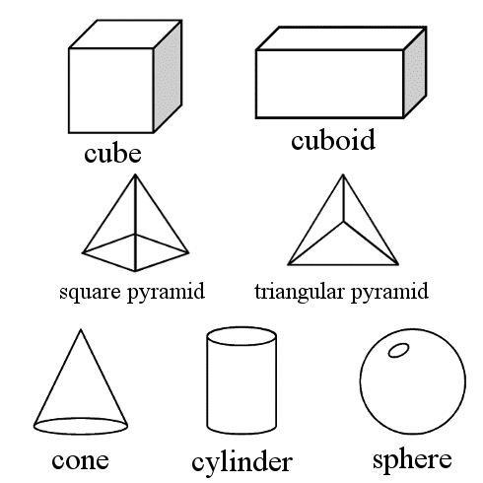

* Cube: a solid whose faces are square. It has six faces, eight vertices, and 12 edges.
* Cuboid: a solid whose faces are rectangular. It has six faces, eight vertices, and 12 edges.
* Square Pyramid: a solid with a square shaped face on the bottom, and four triangular faces adjacent. It has five faces, eight edges, and five vertices.
* Triangular Pyramid: a solid whose faces are triangles. It has four faces, six edges, and four vertices.
* Cone: Starting with a circular base, a cone is formed by all line segments that join a point on the circle to a single locus, called the apex of the cone. A cone has two faces, one vertex and one edge.
* Cylinder: A cylinder has circular bases at the top and bottom, and a curved surface in between. You can think of this as being like a single circle “stretched” along a third dimension, or a pair of circles joined by all line segments connecting corresponding points on the circles.
* Sphere: Defined by a central point P, and every point that is equidistant (at a radius of *R*) from the point across three dimensions. It looks like a ball or marble.

**Surface Area of a Prism**

You know by now how to find the area of various polygons. How does this apply to solids? Given a solid, you can determine its surface area – that is, the combined area of all its faces – and its volume, the quantity of 3d space enclosed by the solid.

To start with, let’s consider the surface area of a *prism*. A prism is a particular kind of solid that has a polygon base on one “end,” a second base which is merely a translated copy of the first, and n faces joining corresponding sides of the two bases.

A cuboid is a kind of prism. In order to find the surface area of a prism, you need to determine two things: the base area, and the lateral area.

The base area, denoted B, is the area of one of the bases.

The lateral area, denoted L, is the combined area of all lateral faces – that is, faces that join the two bases. In our cuboid example, all the lateral faces (and the two bases) are rectangles.

Then, you can determine the surface area S by using the following formula:

$S=2B+L$.

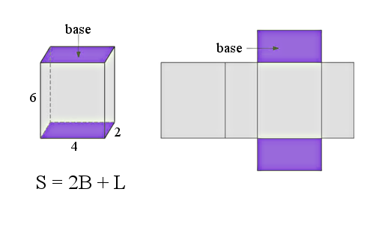

In general, the volume of a prism can be expressed as $V=Bh$, where B is the area of the base, and *h* is the height.

**Cylinders**

Since the bases of a cylinder are both circles, you only need to know its radius to determine their area. Since there are two bases, the area of the “ends” of the cylinder is $2\left(πr^{2}\right)$.

For any piece of the cylinder between the two ends, the length around is $2πr$ (the circumference of a circle), and so the surface area of the exterior face is $A=2πrh.$ Adding the area of the outside face to the area of the two bases gives the surface area of the whole cylinder. So, the surface area of a cylinder is given by $S=2\left(πr^{2}\right)+2πrh$.

Finding the volume of a cylinder follows a similar procedure.

$$V=πr^{2}h$$

**Volume of a Pyramid**

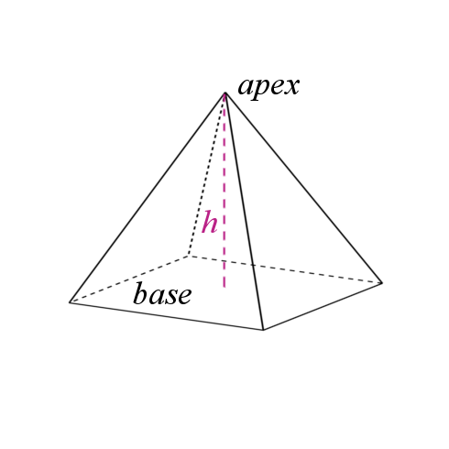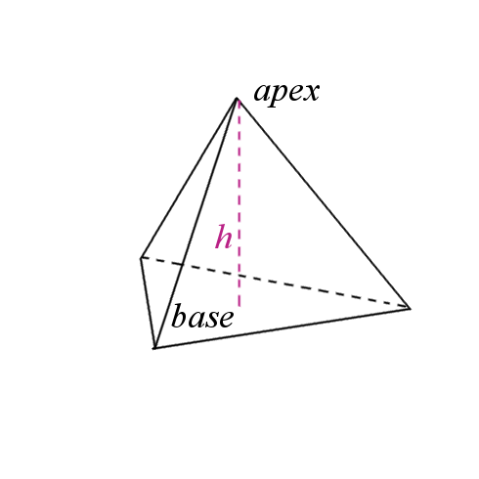

Unlike the comparatively complex prism, pyramids obey a fairly simple rule when it comes to finding their volume. The volume of a pyramid can be found using a single formula:

Volume of a Pyramid = (1/3) * Area of Base * height

$$V=\left(\frac{1}{3}\right)Bh$$

**Cones**

A cone has a feature called the axis, which is an imaginary line that passes through the center of the circular base, and is perpendicular to it. If you imagine the base of the cone as a wheel, the axis would be its axle.

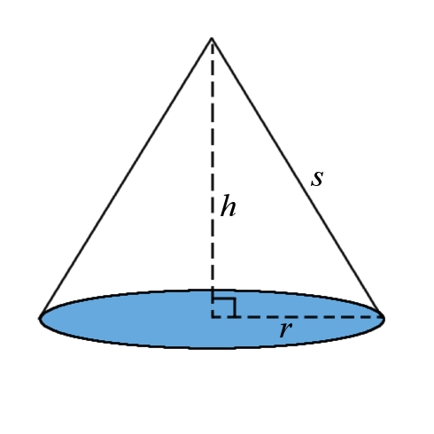

the surface area of a right cone will always be given by: $S=πr^{2}+πrs$

A cone looks sort of like a pyramid, but with circles and sectors instead of polygons and triangular faces. That comparison is valid, it turns out, because the formula for the volume of a cone is exactly the same as the formula for the volume of a pyramid:

$$V=\left(\frac{1}{3}\right)Bh$$

Since the base of a cone is always a circle, then $B=πr^{2}$, and

$V=\left(\frac{1}{3}\right)πr^{2}h$.

**Spheres**

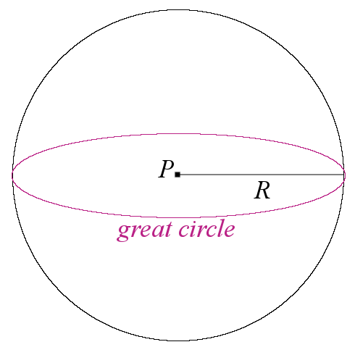

On a sphere, a **great circle** is a circle whose center includes the point at the center of the sphere. On Earth (modeled as a perfect sphere), the Equator and the Prime Meridian are both great circles.

If you can determine the area of a great circle in a sphere, take that area and multiply it by 4 to get the surface area of the entire sphere.

$$S=4πR^{2}.$$

The volume of a sphere is given by $V=\left(4/3\right)πR^{3}.$

**EXTRAS**

**Common Denominators and Least Common Multiple**

**The least common multiple** of two or more numbers is the smallest number which is a multiple of all of those numbers. For example, the multiples of 4 include 4, 8, 12, 16, 20, 24, 28, and 32. The multiples of 6 include 6, 12, 18, 24, 30, and 36. So, the least common multiple of 4 and 6 is 24.

When two fractions are changed in order to have the same denominator, this is called finding a **common denominator**. The common denominator will usually be the **least common multiple** of the two starting denominators. For example, consider $\frac{4}{5}$ and $\frac{6}{8}.$ The least common multiple of 5 and 8 is 40, so to reach a common denominator, $\frac{4}{5}=\frac{32}{40},$ and $\frac{6}{8}=\frac{30}{40}$.

**Greatest Common Factor**

A factor is a number that will exactly divide some other number. For example, the factors of 12 are 1, 2, 3, 4, 6, and 12. The factors of 13 are 1 and 13 - its only factors are 1 and itself. Any number larger than 1 with this characteristic is called a **prime number**. Some common prime numbers are 2, 3, 5, 7, 11, 13, and 17. Note that 2 is the only even prime.

A **common factor** is a number that exactly divides two or more other numbers. The factors of 15 are 1, 3, 5, and 15. The factors of 9 are 1, 3, and 9. The common factors of 15 and 9 are 1 and 3.

A **prime factor** is a factor which is also prime. The prime factors of 15 are 3 and 5.

The **Greatest Common Factor** of two or more numbers is the greatest number which is a factor of all of those numbers. For example, the factors of 24 are 1, 2, 3, 4, 6, 8, 12, and 24. The factors of 36 are 1, 2, 3, 6, 12, 18, and 36. The greatest common factor of 24 and 36 is 12.

**Ordering of Rational Numbers**

Recall that a rational number is a number which can be expressed as a ratio or fraction $\frac{a}{b}$ where a and b are integers.

Example: order the following rational numbers from least to greatest: $0.6,23\text{\%},\sqrt{}$

We can write each of these numbers as a fraction, or as a decimal:

$$0.6=0.6$$

$$23\text{\%}=0.23$$

$$\frac{28}{4}=7$$

$$\frac{5}{8}=0.625$$

$$2=2.$$

Reordering them, we get

$$23\text{\%}=0.23$$

$$0.6=0.6$$

$$\frac{5}{8}=0.625$$

$$2=2.$$

$$\frac{28}{4}=7$$

So, the correct ordering is $23\text{\%},0.6,\frac{5}{8},2,\sqrt{}$

PRACTICE QUESTIONS

1. A car travels 250 miles in 5 hours. How far can the car travel in an hour and a half?

2. June buys $60 worth of apples and bananas. Apples cost $1 each, and bananas cost $2 each. If she buys the same number of apples and bananas, how many bananas did she buy?

3. Find the surface area of a box with square sides 5 feet long, 5 feet wide, and 5 feet tall.

4. Find the volume of a box with rectangular sides 4 feet wide, 3 feet long, and 2 feet tall.

5. A ship travels 40 nautical miles per hour (40 knots) and sails in a straight line for 2 hours. A sea chart has a scale of 1 inch per 10 nautical miles. How many inches apart are the ship’s starting and ending points on the chart?

6. A school has 12 teachers and 18 teaching assistants. The school has 150 students. What is the ratio of faculty to students?

7. Samantha has two part-time job. At one, she earns $21,000 per year. At the second, she earns $11,000 per year. After putting $100 each month into savings, Samantha donates 10% of her remaining income into savings. How much does she donate every year?

8. A box with rectangular sides measures 18 inches wide, 12 inches deep, and 6 inches high. Find the volume of the box in cubic feet.

9. John weighs 180 pounds and wants to lose weight. His goal weight is 150 pounds. About how many kilograms does he need to lose? (1 pound is approximately 0.45 kilograms)

10. The perimeter of a regular hexagon is 42 cm. What is the length of one side?

11. Five students take a test. Four of them score 80, 85, 80, and 90. If the average score is 82, what did the fifth student score?

12. In a carnival game of skill involving tossing a ball into a scoring bucket, Chandra makes 15 attempts, and scores 8 times. What percentage of Chandra’s balls went into the bucket?

13. Randy knows that he has ⅞ of an ounce of food for his fish. His friend gives him another bag of fish food, and a scale tells Randy that the new amount is 0.125 ounces. How much fish food, in ounces, does randy have total? You may convert from fraction to decimal, or from decimal to fraction, to solve.

14. An amusement park adds an automated trolley to take visitors from one area to another. The trolley travels 75 yards in 15 seconds. How long (in seconds) will it take the trolley to carry a guest from the Spook House to the Screaming Falcon roller coaster, if they are 225 yards from each other and the trolley does not need to stop in between?

15. Palermo is a pitcher, and is working on his fastball. Using a radar machine to track the speed of his pitches, he throws five fastballs that register at 87, 89, 93, 91, 80, and 85 miles per hour. Based on this practice session, what is the mean speed of Palermo’s fastball?

16. Siobhan grows tomatoes in her backyard vegetable garden. Last year, her single tomato plant produced 8 pounds of tomatoes. This year, she tried a different soil, and her single tomato plant produced 11 pounds of tomatoes. By what percent did her tomato production increase?

17. Josh wants to carpet his home office. His home office consists of a large room which is 12 feet by 10 feet, and a smaller storage room which is 8 feet by 8 feet. How much carpet (in square feet) will he need to carpet both rooms in his home office?

18. June marks out a triangle-shaped area for an art mural. Before she paints the mural, she needs to cover the area with primer. The triangle’s base is 12 feet long and it is 5 feet tall. How much primer (in square feet) will she need to cover the triangular area?

19. In a parcel of land, Robert fences off a large rectangular field, and splits that field into 3 smaller fields. If the large field is 30 feet by 200 feed, what length of fence does Robert need to fence off the outside, and the dividing lines inside? (Hint: draw a picture of this!)

20. Tulsi has a solid box-shaped container with an open top which is 3 feet long, 4 feet wide, and 4 feet tall. What is the surface area of her container?

21. Suppose Tulsi wished to fill her cuboid container with water. What volume of water (in cubic feet) will she need?

22. Lin has a cylindrical shaped water tank in his home lab. It has a radius of 12 inches and a height of 36 inches, with a lid sealing the top.. If Lin wanted to paint the tank and the lid, how much paint (in square inches) will he need?

23. Now that he has painted his cylindrical tank, Lin wishes to fill it with water. How much water (in cubic inches) will it hold?

24. Parvati designs a cone-shaped coffee filter for a commercial coffee machine. The filter fits a receptacle that is shaped like a cone with a radius of 4 inches and a depth of 4 inches. How much coffee, in cubic inches, could she theoretically fit inside her coffee filter?

25. In a neighborhood, the median household income is $40,000 per year. The highest paid person in the neighborhood gets a promotion which comes with a $15,000 per year raise. What is the value for the new median household income?

SOLUTIONS

1. A car travels 250 miles in 5 hours, so its speed is $250÷5=50$ miles per hour. In 1.5 hours, the car will travel miles.

2. Let x be the number of apples and bananas she bought. Then, $60=1x+2x$.

$$60=3x$$

$$20=x$$

So, she buys 20 bananas (and 20 apples).

3. The box has six sides. Each side has an area of $5×5=25$ square feet. $25×6=150$ square feet in total surface area.

4. The volume is cubic feet.

5. The ship travels a total of $40×2=80$ nautical miles. On the map, this corresponds to a distance of $80÷10=8$ inches.

6. There are $12+18=30$ total faculty. The ratio of faculty to students is 30:150, or 1:5.

7. At $100 per month, each year Samantha puts $\$100×12=\$1200$ into savings. Her total annual income is $\$21,000+\$12,000=\$33,000$. Subtracting what she puts into savings, Samantha has $\$33000−\$1200=\$31800$ left. If she donates 10% of this to charity, then she donates $\$31800×0.10=\$3180$ to charity each year.

8. First we need to convert the dimensions from inches to feet. Since 1 foot is 12 inches, we can divide each dimension by 12 to get its length in feet.

$$18÷12=1.5$$

$$12÷12=1$$

$$6÷12=0.5$$

Then, the volume of the box is $l×w×h=1.5×1×0.5=0.75$ cubic feet.

9. John wants to lose $180−150=30$ pounds. This is approximately kg.

10. A regular hexagon has 6 sides of equal length, so each side measures cm.

11. If the average is 82, then the sum of all of their scores is $82×5=410.$

To find the missing score, subtract the others.

$410−80−85−80−90=75$.

The fifth student scored 75.

12.

13. We will convert to decimal. ⅞ = 0.875. Then, $0875+0125=1$ ounce.

If we instead convert to fractions, 0.125 = ⅛, and so ⅛ + ⅞ = 1 ounce.

14. Let’s split the journey into 15-second increments. In the 225 yard path there are $225÷75=3$ 15-second increments for a travel time of $15×3=45$ seconds.

15. mph.

16. Her total increase is 11-8=3 pounds of tomatoes. Percent increase is or 37.5%.

17. He will need $12×10=120$ square feet in the large room, and $8×8=64$ square feet in the smaller room, for a total of $120+64=184$ square feet.

18. The area of a triangle is $\frac{1}{2}bh=\frac{1}{2}\left(12\right)\left(5\right)=\frac{1}{2}\left(60\right)=30$ square feet of primer.

19. He needs the perimeter of the field, plus the length of the dividers.

|  |  |  |
| --- | --- | --- |
|  |  |  |

The large field is 30 by 200, and each of the 2 dividers must also be 30 feet. So, he needs a total of $2\left(200\right)+4\left(30\right)=400+120=520$ feet of fence.

20. The box has a bottom which is 3 feet by 4 feet, two sides which are 3 feet by 4 feet, and two sides which are 4 feet by 4 feet. It has no top. Find the area of the bottom and four sides, and add them together to find surface area.

$\left(3\right)\left(4\right)+\left(3\right)\left(4\right)+\left(3\right)\left(4\right)+\left(4\right)\left(4\right)+\left(4\right)\left(4\right)=12+12+12+16+16=68$ square feet.

21. The fact that the box does not have a top does not impact the volume of water it will hold. This is also $V=l×w×h=3×4×4=48$ cubic feet.

22. The surface area of a cylinder is $S=2\left(πr^{2}\right)+2πrh=2π$ square inches.

23. The volume of a cylinder is cubic inches.

24. The volume of a cone is cubic inches.

25. The median is not affected by an increase of the maximum data point, even if that change would change the range and mean. So, the median household income is still $40,000 per year.